University Website

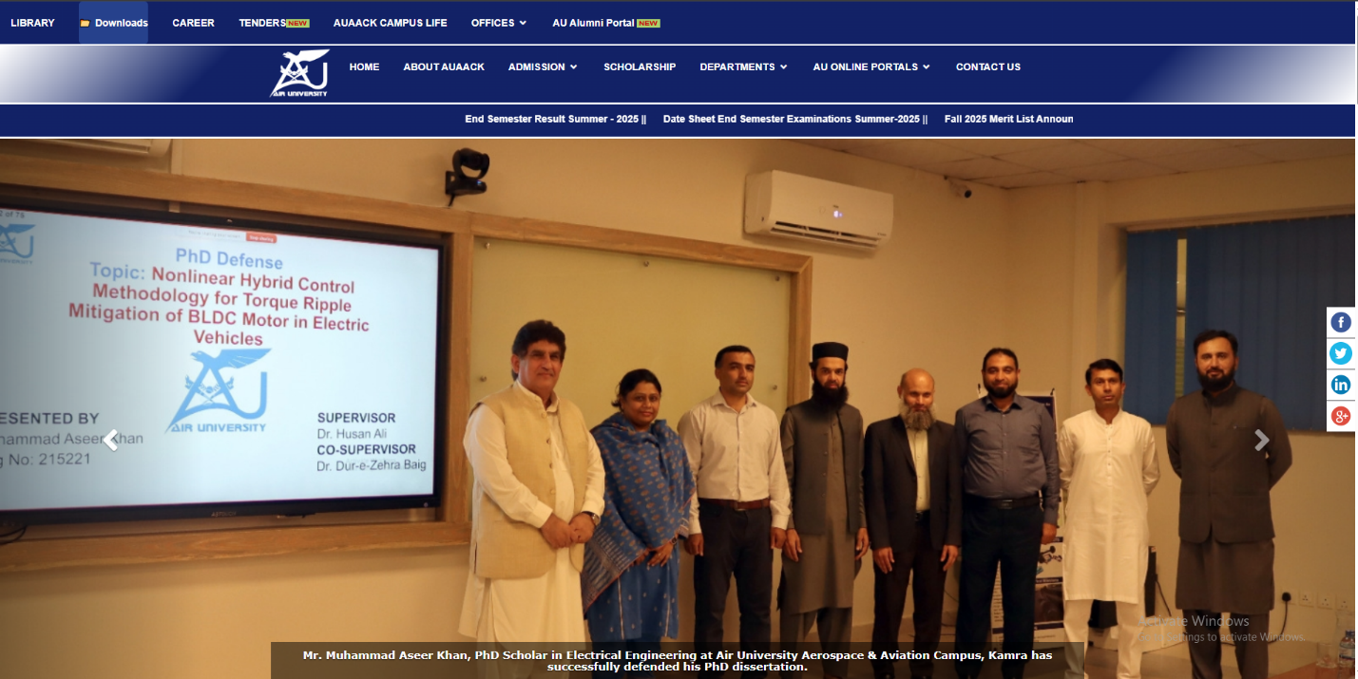

Identify two ICT-related services available for

Students
- Admission portal for students
- Digital library

